Panji Iman Baskoro
171111023

Praktikum Pemprograman Dasar 2

tugascu.java

import java.util.LinkedList;

- public class tugascu {
- static class GraphYolo{
- int edge;
- LinkedList<Integer> adjListArray[];

- GraphYolo(int edgy) {
- this.edge = edgy;

- adjListArray = new LinkedList[edgy];

- for (int i = 0; i < edgy; i++) {
- adjListArray[i] = new LinkedList<Integer>();
- }
- }
- }
- static void add_ee(GraphYolo graph, int node_awal, int node_tujuan) {
- graph.adjListArray[node_awal].add(node_tujuan);
- graph.adjListArray[node_tujuan].add(node_awal);
- }

- static void print(GraphYolo node_graph) {
- for (int i = 0; i < node_graph.edge; i++) {
- System.out.println("Angka tetangga dari " + i + " yaitu : ");
- System.out.println("--------------------------------------");
- System.out.print("Head "+ i + " == ");
- for (Integer node_list : node_graph.adjListArray[i]) {
- System.out.print(" -> " + node_list);
- }
- System.out.println("\n");
- }
- }
- public static void main(String args[]) {
- int odge = 5;
- GraphYolo graph = new GraphYolo(odge);
- add_ee(graph,0,3);
- add_ee(graph,0,1);
- add_ee(graph,1,4);
- add_ee(graph,2,2);
- add_ee(graph,1,4);
- add_ee(graph,1,3);
- add_ee(graph,3,4);
- System.out.println("Adjacency List pada Graph");
- System.out.println("============================");
- print(graph);
- }
- }

output dari program :

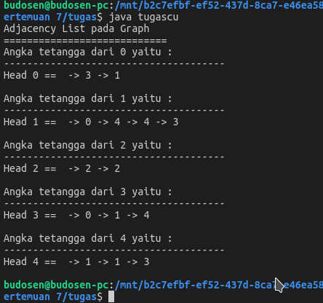

Saya menggunakan library utility LinkedList yang sudah tersedia di java, yaitu java.util.LinkedList

